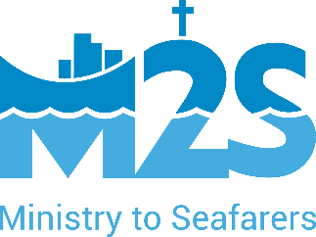

**Report to Classis Quinte**

**May 2024**

**Chaplain Michelle DePooter**

After a busy Christmas parcel season, the winter months are quieter. Ships continue to arrive in Montreal, even though the St. Lawrence Seaway is closed. Due to weather, we often have ships stay longer than usual, allowing us to get to know the crew and have conversations with them.

This year, we had many conversations with seafarers about their faith because Lent and Ramadan both happened at the same time of year. It is always a wonderful to be able to encourage seafarers in their faith, to share our faith with them, and to learn about how they practice their faith. One common theme is the challenge of maintaining faith practices when they don’t have a chance to visit a church or other place of worship on a regular basis, and when others on their ships aren’t as devout.

During the spring months, we welcomed several groups of students from different schools in Montreal and Ontario. We are always thrilled to show new people what we do because most have no idea about the port, ships, or seafarers. When we have groups visit, we try to offer an activity. This year, we invited the students to paint the cloth bags that we use for our Christmas parcels. The results were stunning!

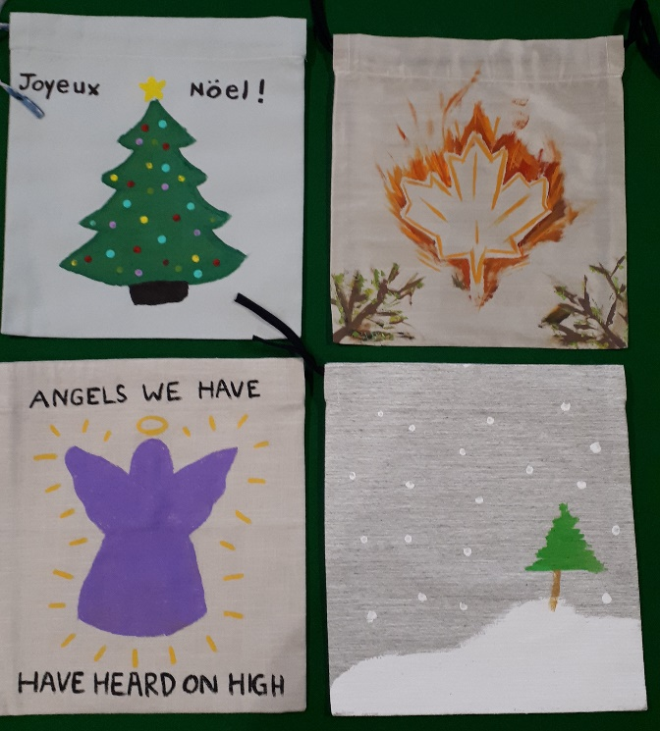 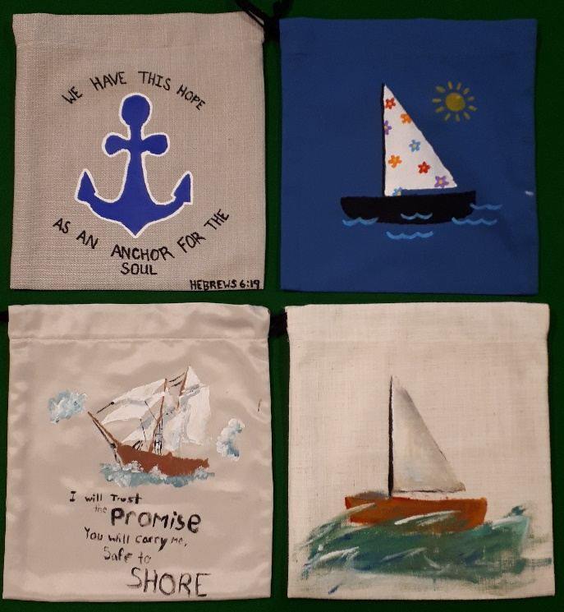

Thank you for your continued prayers and support as we care for the physical, emotional, spiritual and justice needs of all seafarers.

Thank you!